The Nature of Software
The software is instruction or computer program that when executed provide desired features, function, and performance. A data structure that enables the program to adequately manipulate information and document that describe the operation and use of the program.
Characteristic of software:
There is some characteristic of software which is given below:
- Functionality
- Reliability
- Usability
- Efficiency
- Maintainability
- Portability

Functionality
It refers to the degree of performance of the software against its intended purpose.
Functionality refers to the set of features and capabilities that a software program or system provides to its users. It is one of the most important characteristics of software, as it determines the usefulness of the software for the intended purpose. Examples of functionality in software include:
- Data storage and retrieval
- Data processing and manipulation
- User interface and navigation
- Communication and networking
- Security and access control
- Reporting and visualization
- Automation and scripting
The more functionality a software has, the more powerful and versatile it is, but also the more complex it can be. It is important to balance the need for functionality with the need for ease of use, maintainability, and scalability.
Required functions are:
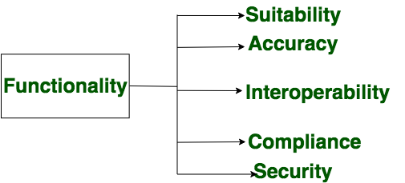
Functionality

Reliability
A set of attributes that bears on the capability of software to maintain its level of performance under the given condition for a stated period of time.
Reliability is a characteristic of software that refers to its ability to perform its intended functions correctly and consistently over time. Reliability is an important aspect of software quality, as it helps ensure that the software will work correctly and not fail unexpectedly.
Examples of factors that can affect the reliability of software include:
- Bugs and errors in the code
- Lack of testing and validation
- Poorly designed algorithms and data structures
- Inadequate error handling and recovery
- Incompatibilities with other software or hardware
To improve the reliability of software, various techniques, and methodologies can be used, such as testing and validation, formal verification, and fault tolerance.
Software is considered reliable when the probability of it failing is low and it is able to recover from the failure quickly, if any.
Required functions are:
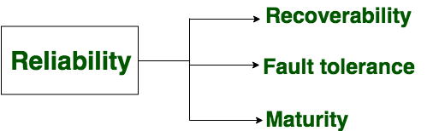
Reliability

Efficiency
It refers to the ability of the software to use system resources in the most effective and efficient manner. The software should make effective use of storage space and executive command as per desired timing requirements.
Efficiency is a characteristic of software that refers to its ability to use resources such as memory, processing power, and network bandwidth in an optimal way. High efficiency means that a software program can perform its intended functions quickly and with minimal use of resources, while low efficiency means that a software program may be slow or consume excessive resources.
Examples of factors that can affect the efficiency of the software include:
- Poorly designed algorithms and data structures
- Inefficient use of memory and processing power
- High network latency or bandwidth usage
- Unnecessary processing or computation
- Unoptimized code
To improve the efficiency of software, various techniques, and methodologies can be used, such as performance analysis, optimization, and profiling.
Efficiency is important in software systems that are resource-constrained, high-performance, and real-time systems. It is also important in systems that need to handle a large number of users or transactions simultaneously.
Required functions are:
Efficiency

Usability
It refers to the extent to which the software can be used with ease. the amount of effort or time required to learn how to use the software.
Required functions are:
Usability

Maintainability
It refers to the ease with which modifications can be made in a software system to extend its functionality, improve its performance, or correct errors.
Required functions are:
Maintainability

Portability
A set of attributes that bears on the ability of software to be transferred from one environment to another, without minimum changes.
Required functions are:

